St. Mary’s CE Primary School Forest School EYFS long term plan
This is an overview of ideas but not set St. Mary’s Forest School is child led and goes with their interests and
things they discover. There is a focus on the seasons in the forest

Year group | Autumn 1 | Autumn 2 | Spring 1 | Spring 2 | Summer 1 | Summer 2
Nursery | Establishing boundaries,  1,2,3 Where are you?  Forest school song.  Expectations for the forest, play expectations, keeping you safe  Rules of forest, keeping you safe, each other and looking after the space we are in.  Confidence in the woods  Modelled play, what can we do in the woods?  Opportunity for free play and exploration.  License to get dirty and explore mud – puddle jumping, mud kitchen.  Use of the mud kitchen, what can we make. How do we use it?  Mud play  Signs of Autumn, leaves of different colours.  Making mud paint  Use of our senses, what can we see, hear, smell  Created art from natural materials | Boundaries  Games  Collection of twigs and sticks for fire lighting.  Finding seeds.  Stick carrying, how to do this safely.  Tree climbing  Lighting first fire  - How to be safe, teach fire side rules – games around this.  Pumpkin soup around the fire  Natural sparklers – Tie a pipe cleaner for sparklers  Bonfire night  Toasting marshmallows  How is the forest getting ready for winter?  Feeding the birds, pine cone feeder,  Palm drill decorations  - Can use a palm drill | Lots of physical games, Simon says, Forest eye spy  Floor is lava.  Hanging ice decorations.  Bird feeders  Season changes in the forest, what has happened?  Hot chocolate/squash  - How to be safe, teach fire side rules – games around this.  - Use of pulleys and buckets in the woods  - Mud kitchen  - Natural play  Building dens with pegs with support  Early signs of Spring – bluebells, daffodils, tulips. | Nest building  Go find it, different  Bird identication  Know the names of two birds that live in the forest.  Twit tu woo where are you?  Listen to the sounds of forest, what can you hear ?  More independent child led play  Plant and tree identification – know 2 trees that grow in the forest.  Mud kitchen, adding different items from the forest floor.  How has the forest changed?  Signs of Spring | What can I do in the forest independently?  Encouraging tree climbing to different spaces.  Crawling, scrambling over under obstacles  Summer scavenger hunt.  Making faces  Child led play  Minature treasure boxes, children to look around the woods for items to fill in.  Art in the woods – paint creation, use of different surfaces. Can make woodland paint.  Woodland faces using natural items | Loose parts play  Bug hunts – use of magnifying glasses  Identification  Story corner  Child led play  Stick caterpillars  Know the names of some minibeasts that live in the forest.  Use of our senses, what can we see hear and feel?
Books | 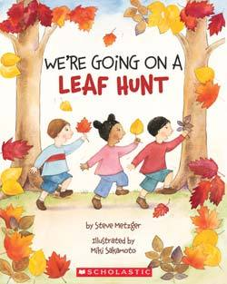  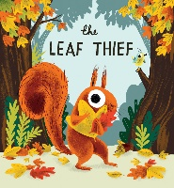 | 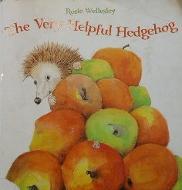  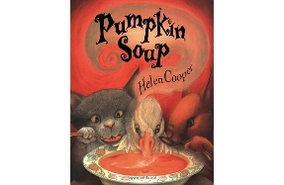 | 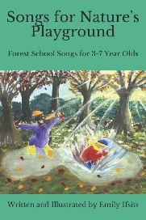  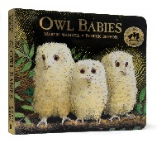 | 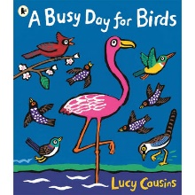  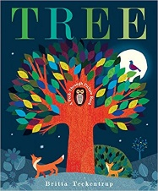 |  | 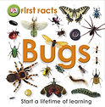  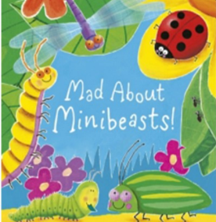
Idea inspiration | Collecting Autumn leaves  Sorting into colours  I wonder why they have changed colour?  Transient art in the woods, what can we use.  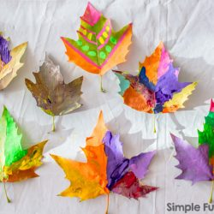  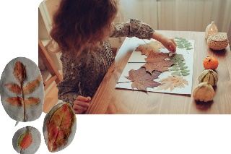  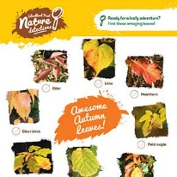 | Salt dough/clay hedgehogs  Cheerio pipecleaners  Sparklers 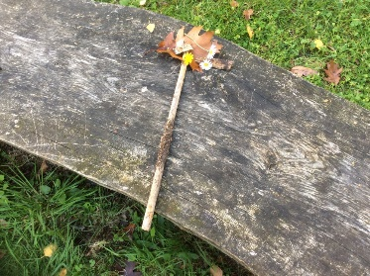  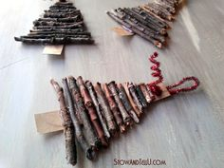  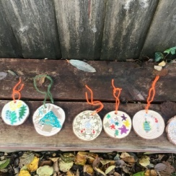 | Where do owls live?  Finding different size branches for Sarah, Percy Bill  - Making a house of sticks for the third little pig  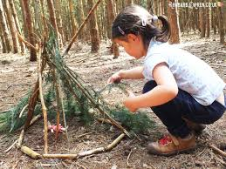  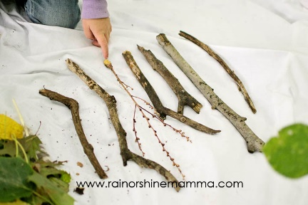 | Nest building for different size birds – knowledge of bird size where they build nests.  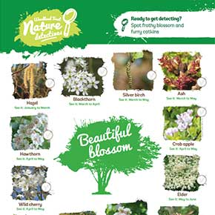 | 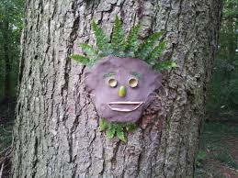  Can you make your face in the woods.  Making rope swings  Climbing webs  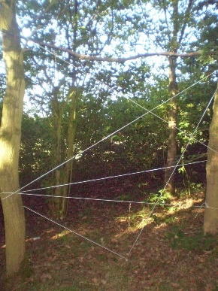 | 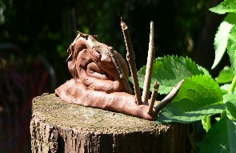  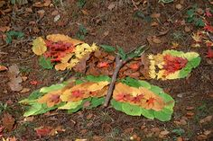
Reception | Boundaries  Team games/shadow tig  How to be safe in the forest.  Free play and exploration in the forest, what can we do?  Rules and expectations, look after ourselves, friends and the people around us.  Mud kitchen following recipes.  Simple plant identification.  Salt dough, making prints from natural objects.  Autumn treasures in the woods.  Autumn leaf necklaces  Autumn mud paint making.  Paintbrushes in the woods  Modelled play in the woods, showing the children what to do.  Imaginary play | Free play and exploration in the forest, what can we do?  Rules and expectations, look after ourselves, friends and the people around us.  Lighting first fire  - How to be safe, teach fire side rules – games around this.  Eating food cooked round a campfire, toasting marshmallows.  Potions in the mud kitchen, teaching children to use imagination  Terrific tales – Gingerbread man, stories around the fire circle.  Making wands – Tying ribbon around a wand.  Season changes in the woods, what has happened to the leaves.  bird seed cakes,  Popcorn garlands.  Sing Christmas songs round campfire  Warm apple juice squash.  Tree decorations  Using a hammer and nails | Active games in the forest  Floor is lava  Tree climbing  Hibernating animals  Talking about animals that hibernate  Making little dens with sticks for woodland creatures  What does winter look like it in the woods – Identify the seasons in the forest.  Safe use of secateurs and loppers.  Child led play  Wood collection  Repetition of fire laying and fire lighting  Making popcorn  Hot chocolate | Know 3 trees that grow in the forest  More independent child led play  What animals live in the woods?  Natural paintbrushes, collecting natural colours to make paint. – How have the colours changed  Planting seeds, life cycles of plants in the forest  How has the forest changed? | Mud kitchen bake off, children to introduce items that they have made.  Map of forests  Physical maps using natural items of the forest.  Create a forest trail, sticks for arrows | Laying trails  Treasure maps  Problem solving  Team games  More independent child led play  Whittling – Can make a mast for a ship  Pirates - team games that children come up with.  Treasure as prompt  Summer in the forest, what does this look like?
Books | 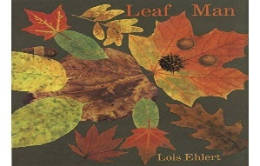  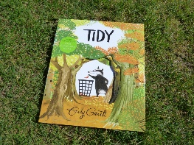 | 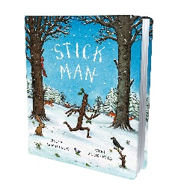  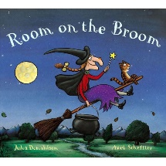 | 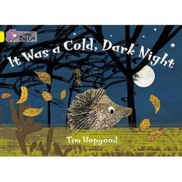 | 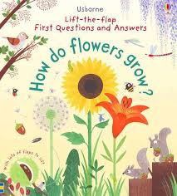  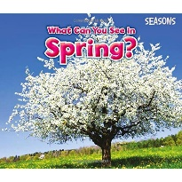 | 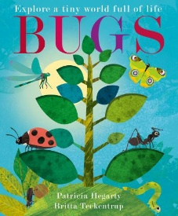 | 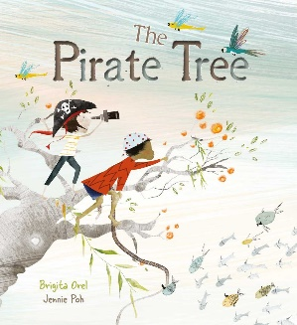
Ideas inspiration | 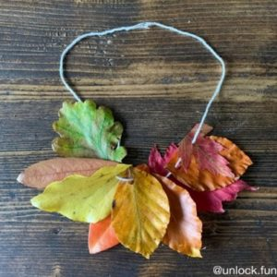  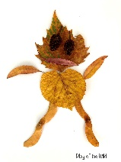  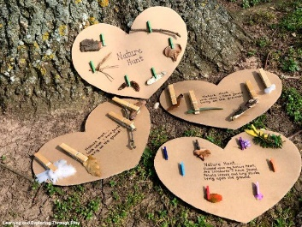 | 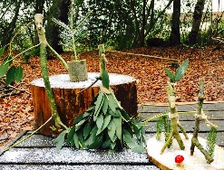  Making broom sticks in the forest.  Wands  Spell words  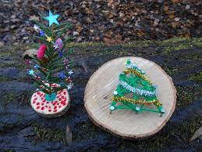 | 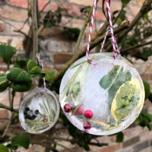  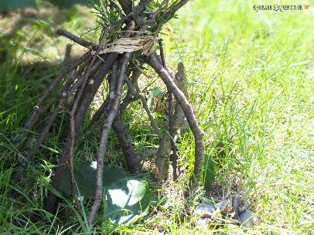 | Planting seeds and bulbs ready for next year.  Look at buds on trees, what they turn into  Elder blossom | 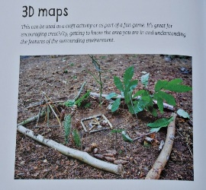  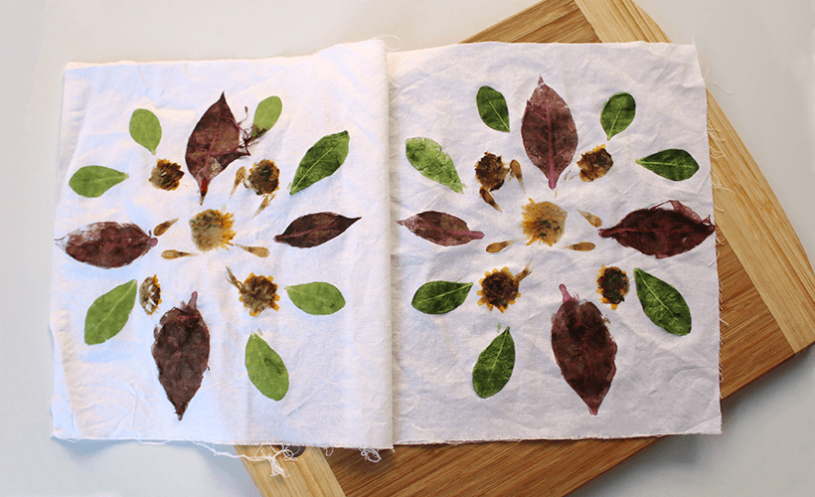 | 