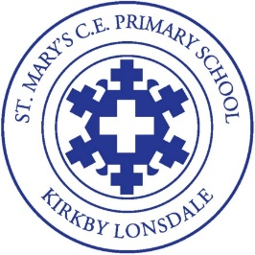
St. Mary’s School Forest School progression of skills EYFS

Class | Knowledge | Experience | Skills
Nursery | I can identify the seasons in the woods.  I can identify two different types of tree  I can name two different woodland birds.  I know how to look after the forest and use materials. | I have eaten two different foods cooked over a fire  I have swung in a hammock  I have made a den using tarps and pegs with help.  I have created art from natural materials.  I have found and jumped in muddy puddles.  I have played lots of new games.  Listened to the sounds of the forest.  I can know where different animals live and can make habitats for them.  I have created recipes in the mud kitchen | I can tie pipe cleaners around a stick.  I can make woodland paint.  I can cut wool and string independently.  I can use a palm drill.
Reception | I can identify the seasons in the woods and say how they have changed, lost leaves, buds etc.  I can identify 3 different types of tree and talk about it.  I can name two different woodland birds and explain what colour it is.  I can talk about creatures that live in woods in our country.  I can recognise | I have swung in a hammock  I have made den using tarps and pegs independently.  I can talk about animals that come out at night.  I have eaten food cooked over a fire and helped to make some of it.  I have followed recipes in the mud kitchen.  I can talk about what I have made to other children.  I have made a habitat for animals  I can talk about some animals that hibernate.  I can use loose parts play in the woods and add other materials to this.  I can talk about how trees grow | I can use hape zoma to make prints.  I can tie ribbon around a string.  I can use a potato peeler to whittle a stick.  I can make woodland paint using natural items.  I can use a hammer and nails  I can make a musical instrument.  I will be able to use secatuers safely

