Policy for Writing

St Mary’s CE School, Kirkby Lonsdale

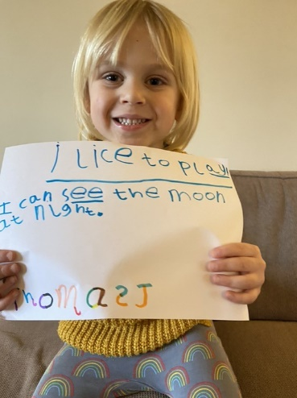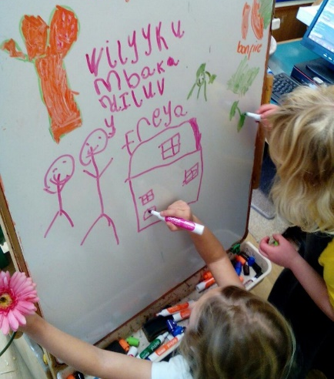

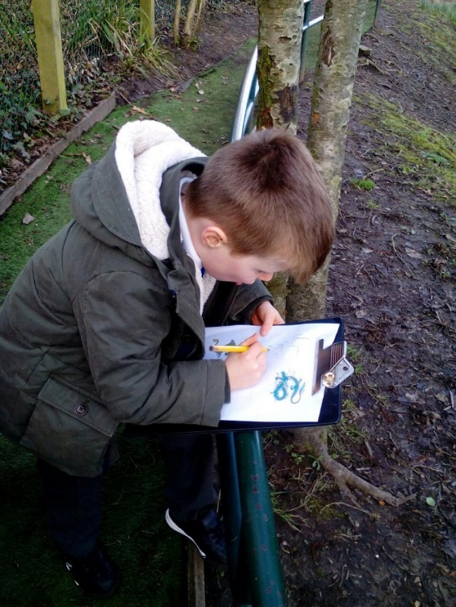

Introduction

This policy outlines the teaching, organisation and management of how Writing is taught at St.Mary’s CE School.
Aims and Objectives
For Children to:
- Choose to write for pleasure
- Understand that writing is an essential skill for everyday life
- Write in creative and imaginative ways
- Write independently
- Have a “love” of words
- Experience a range of purposes and forms of writing
- Communicate in writing clearly, confidently and appropriately, demonstrating an awareness of a variety of purposes and audiences
- Be inspired by a broad and balanced cross curricular curriculum with Literacy at the centre
- Have a fluent joined handwriting style ( see Handwriting Policy)
- Confidently segment words and have strategies to remember tricky words (see Reading and Phonics Policy)
- Present their writing to a high standard at each of the stages of the writing process: planning, drafting, editing and re-editing

Learning and Teaching in Literacy at ST Mary’s CE Primary School is outlined in the EYFS Curriculum and the English National Curriculum.
The Literacy teaching at St Mary’s CE Primary School is characterised by the following:
- Children will be involved in reading, role play, discussion and analysis of the text type before writing.
- All adults in school enthusiastically model writing for pleasure and purpose
- Writing tasks are delivered in meaningful contexts from Nursery to Year 6
- Encouraging the children to write independently from an early stage through child initiated emergent writing and adult initiated guided writing
- Providing the children with the opportunity to participate in role-play and speaking and listening activities to enhance their creative flair and writing voice (see Speaking and Listening Policy)
- The teaching of the synthetic, systematic phonics to supporting writing and encourage accuracy and speed using the principles to teach, practice and apply (also see the Reading and Phonics Policy)
- Well planned lessons/sessions with clear learning intentions and success criteria
- Providing the opportunity for the children to apply their written skills to all areas of the curriculum and expect children to write at a sustained high level, matched to their potential and current writing level, in any context in which they write.
- Stimulating and thought provoking displays/working walls
- Writing tasks/activities will be appropriately matched to individual abilities in the classroom (differentiation), with realistic targets identified and planned for
- Stimulating and challenging working walls which display the writing process
- Use of ICT throughout the writing process
- Opportunities for self-assessment and peer assessment (Assessment for Learning)
- Regular assessment informing next step planning, intervention and individual group targets
- Celebrate personal, group and class writing achievements
- Visits from “real” authors and fun curriculum weeks

Teaching and Learning Style
When teaching we focus on motivating children and building on their skills, knowledge and understanding of the English curriculum through:
- Providing a balanced writing curriculum comprising of shared writing, guided writing, talk for writing and independent writing
- Shared writing where the teacher models, demonstrates and scribes the writing of the text and the children contribute their thoughts and ideas to the process
- Regular Guided writing from Reception to Y6 teaching a specific skill and leading to independent writing
- Guided writing targeting groups of children with specific need throughout the writing process
- Regular opportunities for extended independent writing
- A well organised and planned handwriting scheme and assessments ( see Handwriting Policy)
- Encouraging children to “Think it, Say it, Write it, Read it”
- Encouraging children to always do their best writing in every area of the curriculum
- Regular dedicated time to develop spellings, grammar and punctuation
- Making important links between reading and writing
- Providing a wide range of quality reading materials
- Provide opportunities and resources to read for a range of purposes across the curriculum
- Provide story props, puppets and artefacts for retelling stories
- Techers to set child friendly targets taken from the Kirklees Criterion Scale which are communicated to the children and their parents.
- Planning will reflect visual, kinaesthetic and auditory learning styles, and the learning ethos of the school , with motivational, purposeful activities

Assessment and Feedback
(Also refer to the Assessment and Planning Policy)
Assessment and feedback are integral to the teaching of writing at every stage. At St Mary’s CE Primary School this includes:
- Learning Objectives and Success Criteria that are clear and explicit
- Assessing the children’s writing using Kirklees criterion scale
- Building a writing portfolio of writing assessments from their first piece of assessed writing in Reception to their final piece of assessed writing Year 6
- Assessing independent writing on entry (Sept), at the end of the Autumn Term (Dec), at the end of the Spring Term (March/April) and at the end of the Summer Term (June)
- Assessing the younger children of SEN children through observations, discussions and questioning
- Self-assessment and peer assessment against the success criteria of a lesson
- Assessment of Learning
- Completing Development Matters grid on entry and every term for Nursery and Reception
- Reporting the writing and phonics assessments tot eh Head Teacher and the English Subject Leaders at the end of each term
- Setting targets for the next half term which they will work towards on all pieces of writing (independent and guided) and communicating them to children and their parents. Copies of these targets are to be made into bookmarks and/or attached to their Literacy/Topic books
- Carefully tracking phonic skills through regular phonic assessments
- Taking the SATs for year 2 (where appropriate) and Year 6
- Giving verbal feedback from adult linked to success criteria
- Giving written feedback including closing the gap prompts (see appendix for examples) and time to improve.

Responding to pupils’ diverse learning needs
All the children are encouraged to achieve their potential and enjoy writing through:
- Identify support groups
- Implementing short term or longer term plans that are closely monitored and reviewed
- Booster groups for basic skills such as handwriting/fine motor skills, spelling and grammar

Monitoring and Review
At St Mary’s, we have a rigorous monitoring cycle, which includes the following
- The Head Teacher and/or Subject Leader observe the quality of learning and teaching in Literacy relating to teachers Professional Development targets, peer mentoring and drop ins
- The Subject Leader monitors planning, do book scrutinises and interviews with pupils every term. Then the feedback and targets are given to each class teacher. Follow up INSET is planned to address any areas to develop
- Audits and identification of areas for development through SATs analysis; termly writing assessment analysis; work sampling, data analysis.
- Teacher questionnaires and feedback
- Any areas identified as areas to develop inform the School Improvement Plan

Display and the English Environment
Every opportunity is taken to create a lively, stimulating and challenging environment where attention is drawn to writing as an interesting and enjoyable activity. The writing environment:
- Promotes creative writing for example topic displays and role play areas
- Celebrates children’s achievements in writing including class work, homework and independent writing
- Displays the children’s and adult’s writing at different stages e.g. planning, drafting, editing, and the final piece
- Provides all the tools and writing formats for children to be independent writers e.g. editing pens
- Provides props for writing e.g. puppets
- Includes spelling and vocabulary displays which are updated and differentiated for every class
- A range of good quality, interesting, age appropriate, well organised books
- In the early Years promotes writing in every area indoors and outdoors
- Includes banks of computers (or timetabled time for KS1 and EY)
- Well-resourced phonics areas

Engaging Parents
We recognise that children’s learning is consolidated and extended through partnership and good communication between child-school-home. We encourage a partnership through:
- Communicating with child friendly writing targets
- Homework varying and dependent of the class topic, child’s ability and child’s writing target
- Information evenings for children starting Nursery and Reception informing parents about how to help children begin to learn to write e.g. fine motor skills, creative ideas, imaginative play
- Encouraging parents to write at home in front of their children
- Sending home pieces of work for children to share with their parents
- Inviting parents to celebrate “Golden” assembly
- Individual parent consultation meetings when required
- Parents are also welcome in school to help with playing Literacy games, supporting small groups in class etc.

Subject Leaders
Teachers hold responsibility for specific subject areas. The responsibilities of the Literacy Subject Leaders include:
- Curriculum coordination including support in preparation of schemes of work and development of assessment
- Monitoring work throughout the school
- Leading review and development of policy as appropriate
- Contribution to School Development planning for Literacy
- Organising, review and ordering of resources
- Providing support to colleagues and leading INSET
- Liaising with other schools and advisory services.

Katie Jamieson
Feb 2020

