Policy for Reading

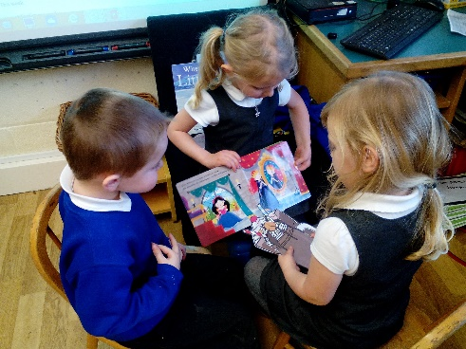
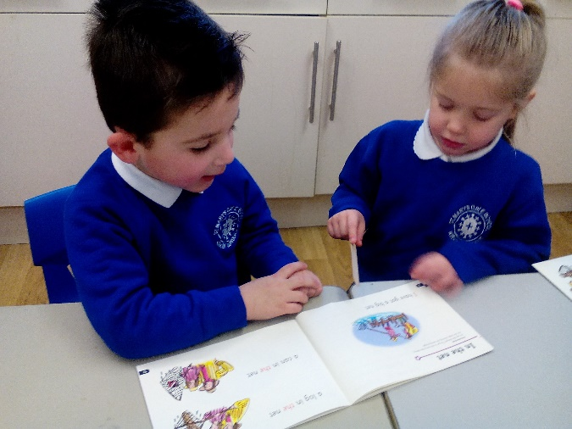
St Mary’s CE School, Kirkby Lonsdale
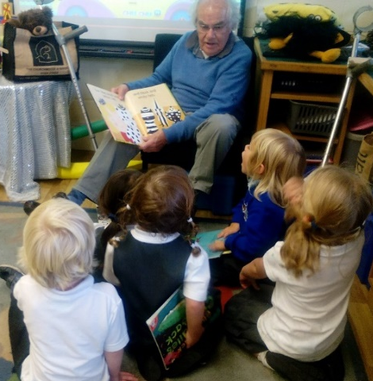

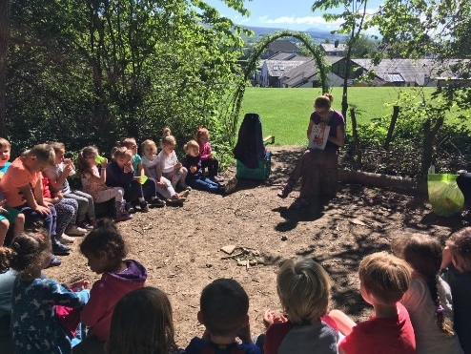

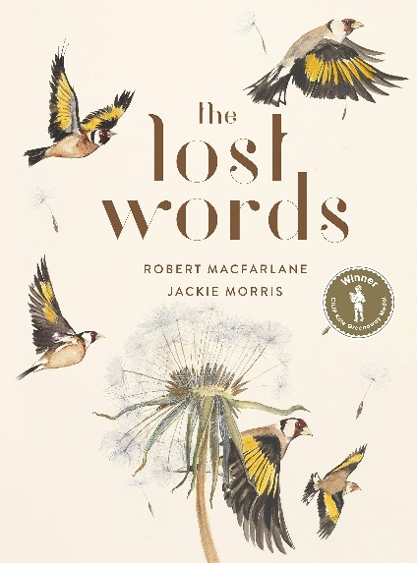
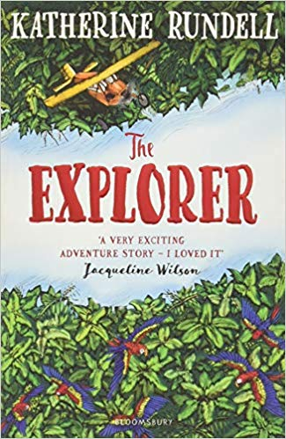

Introduction

This policy outlines the teaching, organisation and management of English taught and learnt at St.Mary’s CE School, Kirkby Lonsdale.
The policy has been drawn up as a result of staff discussion and its implementation is the responsibility of all teaching staff. The responsibility for monitoring and review rests with the English subject leader Katie Jamieson.
The main purposes of this policy are:
- To establish an entitlement for all pupils.
- To establish expectations for teachers of this subject.
- To promote continuity and coherence across the school.
Aims and objectives
The Reading Curriculum:
The 2014 National Curriculum states that pupils should be taught to read fluently, understand extended prose and be encouraged to read for pleasure. Reading is singled out as of extreme importance since through it “pupils have a chance to develop culturally, emotionally, intellectually, socially and spiritually” (p13). Reading allows pupils to “acquire knowledge” and to “build on what they already know” (p13).

At St.Mary’s CE Primary School, staff recognise that reading development is closely linked to that of writing, for it is by reflecting upon and talking about the texts that they encounter that pupils come to understand how writers write and to develop an awareness of the relationship between author and reader. At our school, we strive to make this link clear by providing learning opportunities which are based on quality texts that engage the pupils, immersing them in a rich language environment. Our hope is that children leave our school at the end of year 6 reading fluently, having established a love of reading and with experience of as wide a range of texts as possible.

Objectives
In order to develop fluent, confident readers, practitioners at St.Mary’s CE Primary are expected:
- To follow a systematic approach to the teaching of phonics (see the Phonics Policy);
- To discretely teach comprehension strategies through quality whole class direct teaching and group work (when required);
- To actively promote and foster a love of reading by reading to their own class;
- To further develop children’s vocabulary by actively teaching new vocabulary during; English lessons, other subjects and class reader sessions;
- To make the link explicit between reading and writing.

Aims
For children to:
- Enjoy reading at their own level (focusing on developing decoding, fluency and comprehension);
- Read for pleasure and information;
- Be confident to read individually , in pairs, in small groups and in larger groups;
- Understand that reading is useful and necessary skill for everyday life;
- Read a range of styles and genres independently and with confidence;
- Achieve their full potential as readers through a broad and balanced cross curricular curriculum with English at the centre;
- Acquire skills, concepts and knowledge which enable them to become an effective reader;
- Blend phonemes to read words and confidently recognises common exceptions.

Teaching Approaches and Learning Styles
The 2014 Curriculum divides reading skills into two dimensions:
Word reading/ decoding
Comprehension

We recognise that both these elements are essential to success and we support the acquisition of both sets of skills through various methods. We acknowledge that these areas are clearly linked to the other aspects of English learning: speaking and listening, writing, grammar and vocabulary. We also understand that reading is a developmental process and part of life-long learning and we encourage and praise children at every stage of it.

Learning and Teaching
Learning and teaching in English at St Mary’s CE Primary School is characterised by the following:
- All adults inspire, model and communicate their love of reading
- Schemes of work that follow the National Curriculum and The Early Years framework (e.g. Read Write Inc)
- Teachers have a secure subject knowledge and are aware of popular children’s authors
- Quality teaching of reading and vocabulary from an early age
- Fast, synthetic, systematic phonics teaching
- Cross curricular reading activities are purposeful and meaningful
- First hand experiences
- Well planned lessons/sessions with clear intentions and success criteria
- A variety of teaching styles and consideration of individual learning styles allowing all children to access the reading curriculum effectively
- An easy accessible, comfortable reading environment
- Wide use of appropriate, meaningful and stimulating reading resources including ICT
- Opportunities for self-assessment and peer assessment (Assessment for Learning)
- Regular assessment informing next step planning, intervention groups and individual targets
- Equal and inclusive access to all aspects of learning and teaching of reading
- A strong link between home and school including all adults in school to promote reading at home
- Celebrate personal reaching achievements, for example, book awards and reading heros.
- Whole school reading events to promote a love of reading
- Encouraging members of the community in read with/to the children
- Regular visits to the library van to update classroom books and
- Visits from real authors

Learning and Teaching Process
When teaching, we focus on motivating children and building on their skills, knowledge and understanding of the English curriculum through:
- Teaching a range of strategies ( see the Searchlights model)
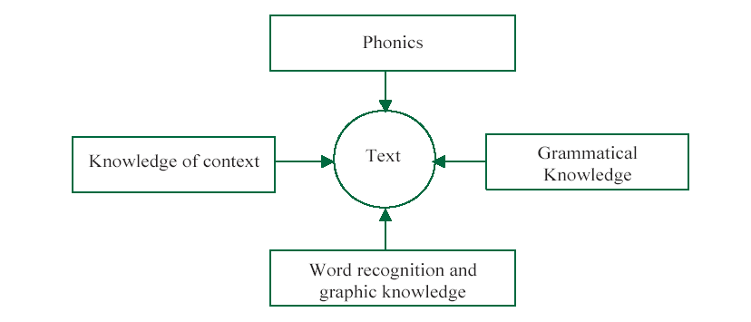
- Regular shared reading led by the teacher to demonstrate reading strategies ( including phonics) in a meaningful way including modelling active engagement with the text: opportunities for children to interact and collaborate: demonstrate how fluent readers monitor and clarify their understanding ( for example encouraging reciprocal teaching – predicting, clarifying, questioning and summarising); and opportunities to interpret and respond to text
- A rich and regular “read aloud” programme
- Teachers model comprehension skills and demonstrate
‘reading as a reader’ and ‘reading as a writer’.
- Regular opportunities for independent, extended reading
- Provide a wide range of quality reading materials
- Provide opportunity and resources to read for a range of purposes across the curriculum
- Provide story props, puppets, and artefacts for retelling stories (where necessary)
- Book Borrow/Exchange available to all children throughout the year. Children who do not have access to books at home are encouraged to use the book borrow/exchange on a regular basis

Teaching Reading and Phonics (also see the Phonics Policy)
In Nursery all the children are encouraged to:
- Enjoy looking at and reading books from an early age;
- Engage with books that fire their imagination and interest;
- Have a core set of books read repeatedly throughout the year and then several copies of the books in the class collection for children to use to retell the stories;
- Stories and Nursery rhymes every day;
- Choose and peruse books freely as well as sharing them when read by an adult or older children; and
- Value and respect books and reading materials.
In Reception:
- The children begin by telling wordless stories.
- The children take home quality texts to read at home with parents every week.
- The children have a reading session as part of their phonics session at least three times a week and independent or small group reading sessions every week.
- Phonics is taught using Read Write Inc (refer to Phonics Policy).
- Early Years Practitioners hold a parents meeting to discuss the importance of reading, to demonstrate reading strategies, emphasise the importance of reading and to organise the reading resources.
- The children are introduced to common exceptions/tricky words/red words in school and take these home to learn to read.
- The books sent home match the phonics sounds being taught in school. Book bag books (Read Write Inc) go home with the children once the corresponding book has been read with the group in school.
- New vocabulary is taught through books read in class and repetition activities.
- Continuous provision activities relate to stories being read in school.
- Reception class have identified core books for the year group.
In Key Stage 1 and 2
- The children continue to progress through Read Write Inc Phonics and Reading and by the time they finish Autumn term in Year 2, the majority of children can read independently, fluently and confidently for enjoyment and for information.
- The children continue to read with their Read Write Inc reading group at least three times per week including decoding, fluency and comprehension.
- Year 1 and 2 have a core set of books they use and teach whole class reading.
- New vocabulary is taught and planned to be introduced through stories and non fiction read in class.
- The children are encouraged to use fluent reader skills taught in Whole Class Reading, for example, scanning and skimming.

Assessment for Learning and Assessment of Learning
(Also refer to the Assessment and Planning Policy)
Assessment and feedback are integral to the teaching of reading at St Mary’s CE Primary School and this includes:
- Learning Objectives and Success Criteria that are clear and explicit;
- Assessing the children using National Curriculum 2014 statements;
- Assessing the children through observations, discussions, their response to the text and questioning;
- Self-assessment and peer assessment;
- Assessment for Learning;
- Carefully tracking phonic skills through regular phonics assessments;
- Reporting the reading and phonics assessments to the SLT and English Subject Leaders at the end of each term;
- Using the Simple View of Reading to group children and set focused targets;
- Completing summative Reading Assessments every term;
- Statutory assessments for Year 2 and Year 6;
- Giving verbal feedback from adult linked to success criteria;
- Giving written feedback in Reading Records or English books;
- Any pupils who are deemed to be underperforming are swiftly identified and participate in booster/intervention sessions which are designed to close the gap between themselves and their peers.

Responding to pupils’ diverse learning needs - Intervention
All the children are encouraged to achieve their potential and enjoy reading through
- Identifying support groups;
- Implementing short term or longer term plans that are closely monitored and reviewed;
- Using the Read Write Inc tracker to identify the lowest 20% children in YR, Y1 and Y2 and implement 1:1 phonics tutoring;
- Encouraging reading partners if children are struggling to read at home. A reading partner might include an older child or adult i.e. an adult at breakfast club or a student from QES.

Display and the Reading Environment
Every opportunity is taken to create a lively, stimulating and challenging environment when attention is drawn to reading as an interesting and enjoyable activity. In each classroom the reading environment has:
- A range of good quality, interesting and age appropriate core books including classical and contemporary books from a variety of authors.
- Books that are easily accessible, well organised and clearly labelled enabling children to function independently.
- Story/non-fiction props and puppets (when appropriate).
- Displays of books with a changing focus on authors or genres or topic.
- Reading displays both teacher and child initiated
- Books relating to class topic.
- Books in the role play areas and continuous provision in the Early Years and Key Stage 1.
- A book area for browsing and space for collaborative reading.
- Multiple sets of good quality core books.
- Phonics resources relating to Read Write Inc Phonics.
- The book area where children can be assured of comfort, peace and quiet to read silently and browse amongst the books
- English working walls are used to demonstrate reading skills and strategies.

Engaging with Parents
We recognise that children’s learning is consolidated and extended through partnership and good communication between children-school-home. We encourage a partnership through:
- Reading meetings in the Early Years;
- Parents meetings to discuss the curriculum expectations in each age group;
- Class information booklets which are circulated at the beginning of the year giving further information about reading in each class;
- Reading tips for parents in the form of reading leaflets, recommending websites or texts, games (when appropriate);
- Communicating child friendly targets (when appropriate);
- Homework relating to reading text or phonics teaching (Book Bag books);
- Homework varying depending on the class topic, child’s ability and child’s reading targets;
- Every child being encouraged to read at home;
- Making constructive comments in reading records;
- Writing encouraging letters or talking to parents who do not read with their children to overcome any barriers;
- Individual parent consultation meetings when required;
- Parents are also welcome in school to help with operating class libraries, hear readers, playing English games, supporting small group work;
- Involvement in book activities involving parents, for example, reading quizzes to complete at home, fancy dress costumes for reading days or taking photos of children reading in strange places.

Monitoring and Review
At St Mary’s CE Primary School we have a rigorous monitoring cycle, which includes the following:
- The Head Teacher and/or Subject Leaders observe the quality of learning and teaching in reading relating to the teachers Professional Development targets, peers mentoring and drop in.
- The English Subject Leader monitor planning, does book scrutinises and reading interviews with pupils when appropriate. The feedback and targets are given to class teachers (where appropriate). Follow up INSET is planned to address any areas to develop.
- Audits and identification of areas for development through SATs analysis, termly reading assessment analysis, work sampling and data analysis.
- Teachers questionnaires and feedback.
- Any areas identified as areas to develop inform the School Improvement Plan.

Subject Leaders Responsibilities
Teachers hold responsibility for specific subject areas. The responsibilities for the English Subject Leader include:
- Curriculum coordination including support in preparation of schemes of work and development of assessment;
- Monitoring work throughout the school;
- Leading review and development of policy as appropriate;
- Contribution to School Development planning for English and Whole School Reading;
- Organisation, review and coordinating of resources;
- Providing support to colleagues and leading INSET;
- Liaising with other schools and advisory services.

Appendix

Assessment: Simple View of Reading

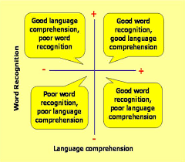

Appendix

Comprehension: Reading VIPERS (Literacy Shed) or Reading with DERIC

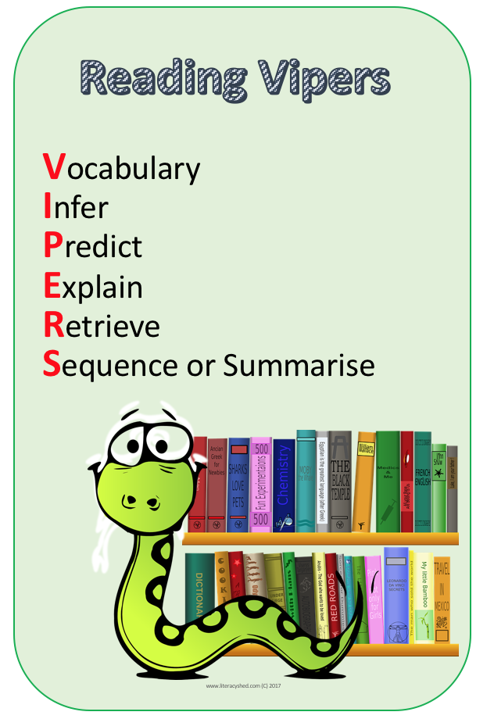
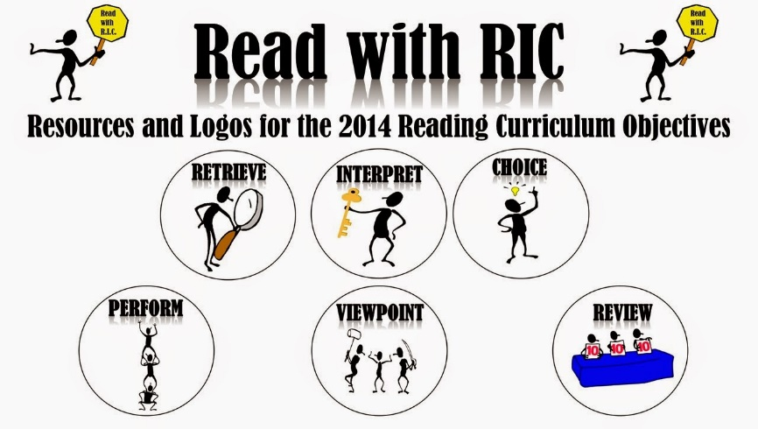

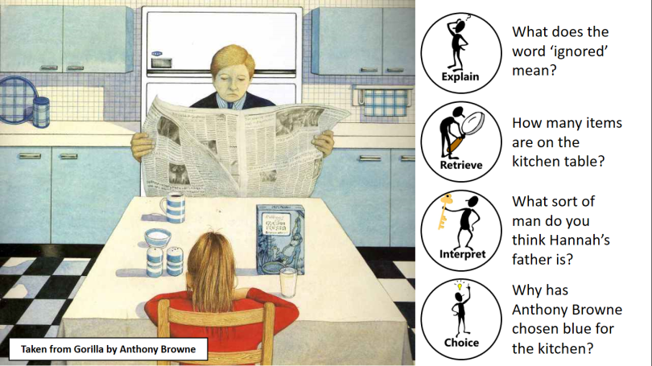

Appendix

Higher Order Comprehension Questions

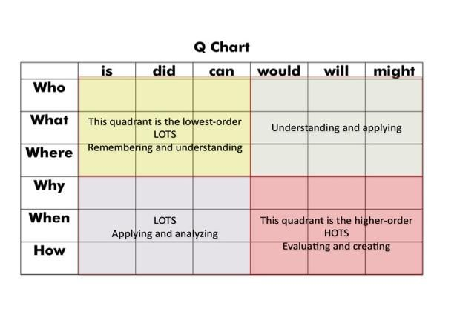

Appendix

Teaching Vocabulary

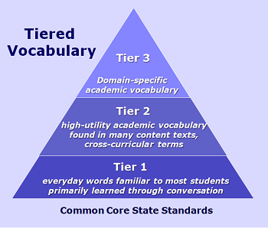

Appendix

National Curriculum 2014

Year 1
Word recognition
Pupils should be taught to:
• apply phonic knowledge and skills as the route to decode words
• respond speedily with the correct sound to graphemes (letters or groups of letters) for all 40+ phonemes, including, where applicable, alternative sounds for graphemes
• read accurately by blending sounds in unfamiliar words containing GPCs that have been taught
• read common exception words, noting unusual correspondences between spelling and sound and where these occur in the word
• read words containing taught GPCs and –s, –es, –ing, –ed, –er and –est endings
• read other words of more than one syllable that contain taught GPCs
• read words with contractions [for example, I’m, I’ll, we’ll], and understand that the apostrophe represents the omitted letter(s)
• read aloud accurately books that are consistent with their developing phonic knowledge and that do not require them to use other strategies to work out words
Comprehension
Pupils should be taught to:
• develop pleasure in reading, motivation to read, vocabulary and understanding by:
• listening to and discussing a wide range of poems, stories and non-fiction at a level beyond that at which they can read independently
• being encouraged to link what they read or hear read to their own experiences
• becoming very familiar with key stories, fairy stories and traditional tales, retelling them and considering their particular characteristics
• recognising and joining in with predictable phrases
• learning to appreciate rhymes and poems, and to recite some by heart
• discussing word meanings, linking new meanings to those already known
• understand both the books they can already read accurately and fluently and those they listen to by:
• drawing on what they already know or on background information and vocabulary provided by the teacher
• checking that the text makes sense to them as they read and correcting inaccurate reading
• discussing the significance of the title and events
• making inferences on the basis of what is being said and done
• predicting what might happen on the basis of what has been read so far
• participate in discussion about what is read to them, taking turns and listening to what others say

Year 2
Word Recognition
Pupils should be taught to:
• continue to apply phonic knowledge and skills as the route to decode words until automatic decoding has become embedded and reading is fluent
• read accurately by blending the sounds in words that contain the graphemes taught so far, especially recognising alternative sounds for graphemes
• read accurately words of two or more syllables that contain the same graphemes as above
• read words containing common suffixes
• read further common exception words, noting unusual correspondences between spelling and sound and where these occur in the word
• read most words quickly and accurately, without overt sounding and blending, when they have been frequently encountered
• read aloud books closely matched to their improving phonic knowledge, sounding out unfamiliar words accurately, automatically and without undue hesitation

Comprehension
Pupils should be taught to:
• develop pleasure in reading, motivation to read, vocabulary and understanding by:
• listening to, discussing and expressing views about a wide range of contemporary and classic poetry, stories and non-fiction at a level beyond that at which they can read independently
• discussing the sequence of events in books and how items of information are related
• becoming increasingly familiar with and retelling a wider range of stories, fairy stories and traditional tales

• being introduced to non-fiction books that are structured in different ways
• recognising simple recurring literary language in stories and poetry
• discussing and clarifying the meanings of words, linking new meanings to known vocabulary
• discussing their favourite words and phrases
• continuing to build up a repertoire of poems learnt by heart, appreciating these and reciting some, with appropriate intonation to make the meaning clear
• understand both the books that they can already read accurately and fluently and those that they listen to by:
• drawing on what they already know or on background information and vocabulary provided by the teacher
• checking that the text makes sense to them as they read and correcting inaccurate reading
• making inferences on the basis of what is being said and done
• answering and asking questions
• predicting what might happen on the basis of what has been read so far
• participate in discussion about books, poems and other works that are read to them and those that they can read for themselves, taking turns and listening to what others say

Year 3 and 4
Word recognition
Pupils should be taught to:
• apply their growing knowledge of root words, prefixes and suffixes (etymology and morphology) both to read aloud and to understand the meaning of new words they meet

Comprehension
Pupils should be taught to:
• develop positive attitudes to reading and understanding of what they read by:
• listening to and discussing a wide range of fiction, poetry, plays, non-fiction and reference books or textbooks
• reading books that are structured in different ways and reading for a range of purposes
• using dictionaries to check the meaning of words that they have read
• increasing their familiarity with a wide range of books, including fairy stories, myths and legends, and retelling some of these orally
• identifying themes and conventions in a wide range of books preparing poems and play scripts to read aloud and to perform, showing understanding through intonation, tone, volume and action
• discussing words and phrases that capture the reader’s interest and imagination
• recognising some different forms of poetry [for example, free verse, narrative poetry]
• understand what they read, in books they can read independently, by:
• checking that the text makes sense to them, discussing their understanding and explaining the meaning of words in context
• asking questions to improve their understanding of a text
• drawing inferences such as inferring characters’ feelings, thoughts and motives from their actions, and justifying inferences with evidence
• predicting what might happen from details stated and implied
• identifying main ideas drawn from more than one paragraph and summarising these
• identifying how language, structure, and presentation contribute to meaning
• retrieve and record information from non-fiction
Year 5/6
Word recognition
Pupils should be taught to:
• apply their growing knowledge of root words, prefixes and suffixes (morphology and etymology), both to read aloud and to understand the meaning of new words that they meet.

Comprehension
Pupils should be taught to:
• maintain positive attitudes to reading and understanding of what they read by:
• continuing to read and discuss an increasingly wide range of fiction, poetry, plays, non-fiction and reference books or textbooks
• reading books that are structured in different ways and reading for a range of purposes
• increasing their familiarity with a wide range of books, including myths, legends and traditional stories, modern fiction, fiction from our literary heritage, and books from other cultures and traditions recommending books that they have read to their peers, giving reasons for their choices
• identifying and discussing themes and conventions in and across a wide range of writing
• making comparisons within and across books
• learning a wider range of poetry by heart
• preparing poems and plays to read aloud and to perform, showing understanding through intonation, tone and volume so that the meaning is clear to an audience
• understand what they read by:
• checking that the book makes sense to them, discussing their understanding and exploring the meaning of words in context
• asking questions to improve their understanding
• drawing inferences such as inferring characters’ feelings, thoughts and motives from their actions, and justifying inferences with evidence
• predicting what might happen from details stated and implied
• summarising the main ideas drawn from more than one paragraph, identifying key details that support the main ideas
• identifying how language, structure and presentation contribute to meaning
• discuss and evaluate how authors use language, including figurative language, considering the impact on the reader
• distinguish between statements of fact and opinion
• retrieve, record and present information from non-fiction
• participate in discussions about books that are read to them and those they can read for themselves, building on their own and others’ ideas and challenging views courteously
• explain and discuss their understanding of what they have read, including through formal presentations and debates, maintaining a focus on the topic and using notes where necessary provide reasoned justifications for their views.

