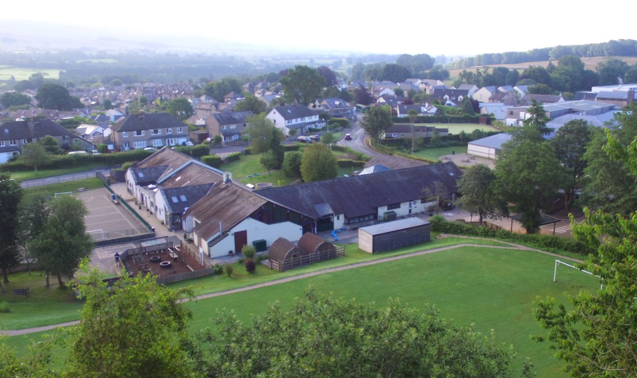

Community
Challenge
Creativity

St Mary’s Subject Intent Document

Our Curriculum Intent at St Mary’s CE School:
To develop a carefully designed, sequential curriculum, underpinned by progressive knowledge and understanding, equipping our children for their future lives. It is aspirational, providing problem solving, challenge and creativity whilst developing character including responsibility, reliability and perseverance. The curriculum ensures the children are able to celebrate uniqueness and diversity and apply their learning to positively impact the local, national and global community.

In order to achieve our Curriculum Intent, we have designed our curriculum around the following Principles of design:
- Core and Progressive knowledge – a minimum entitlement that all pupils will be required to know, grounded in the National Curriculum
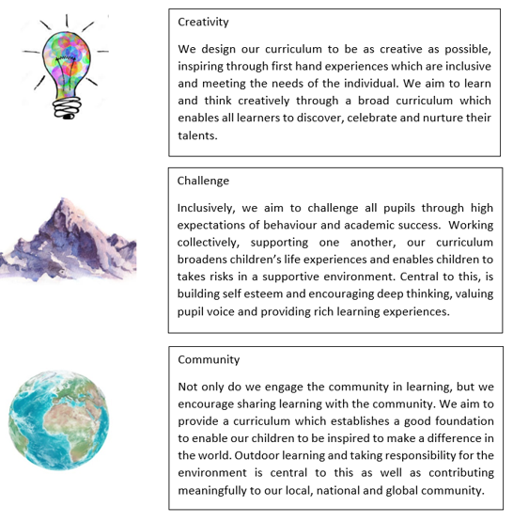

End points of our curriculum:
Principles of design
Aspiration | PP / SEND / HAPS / EAL | Extended experiences | Subject related careers e.g. how learning is applicable / related to real world situation
Core Knowledge | Subject based
Procedural / Powerful Knowledge (skills) | Literacy / numeracy reinforcing opportunities within subjects | Debate / oracy skills and confidence | Opportunities to grapple with big concepts / ideas | 1. Communication  2. Problem solving  3. Resilience  4. Initiative  5. Organisation  6. Teamwork  7. Digital literacy  8. Creativity
Developing Cultural capital | Student Entitlements  (e.g. trips / out of school clubs / residential) | Vocabulary extension and aspiration | Wider reading (stretch & challenge texts) | Engaging with inspirational visits and visiting speakers | School Values:  Trust  Responsibility  Respect  Honesty  Perseverance
Developing Character | Values being lived out in practice | Excellent behaviour for learning | Attendance and punctuality | Independent study skills
Creativity
Identifying and addressing Context specific need Community | Healthy lifestyles (Healthy relationships) | Rural Engagement with Yorkshire Dales and Lake District | Developing Understanding of Diversity within the country and world
Learning is Sequential | Key themes enhanced by Rosenshine’s Principles of Instruction

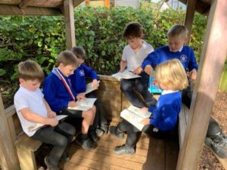

English Intent:
Our intent is comprised of the following 3 sections:
- Our vision for the subject and the purpose it serves for our pupils
- Defining what the key concepts and core domains of knowledge are, that pupils will learn about
- The end points our curriculum is working towards
- Our vision

At St.Mary’s Primary School, we are proud of our text rich learning environment where imagination and creativity can be fuelled. We believe that our inspiring English curriculum develops children’s love of reading, writing, discussing and performing through a carefully designed, progressive curriculum. We recognise the importance of nurturing a culture where children enjoy reading, take pride in their writing and can clearly and accurately adapt their language and style for a range of contexts.
We inspire children to grasp the basic literacy skills to provide them with the tools they need to participate fully as a member of society. We believe that children need to develop a secure knowledge base in English, which follows a clear pathway of progression, enabling them to communicate effectively and creatively through spoken and written language and equip them with the skills they need to become lifelong learners.

- Our key concepts and core domains of knowledge

The National Curriculum for English forms the basis for ensuring continuity and progression through an age-related English curriculum. We ensure that our English teaching and learning provides many purposeful opportunities for reading, writing and discussing. We use a wide range of experiences, quality texts and resources to motivate and inspire our children.

The national curriculum for English aims to ensure that all pupils:

● read easily, fluently and with good understanding
● develop the habit of reading widely and often, for both pleasure and information
● acquire a wide vocabulary, an understanding of grammar and knowledge of linguistic conventions for reading, writing and spoken language
● appreciate our rich and varied literary heritage
● write clearly, accurately and coherently, adapting their language and style in and for a range of contexts, purposes and audiences
● use discussion in order to learn; they should be able to elaborate and explain clearly their understanding and ideas
● are competent in the arts of speaking and listening, making formal presentations, demonstrating to others and participating in debate.

At St.Mary’s:
- Teachers create a positive reading and writing culture in school, where both are promoted and enjoyed.
- Teachers read aloud to their class every day.
- Pupils in Reception and Year 1 (Year 2 and KS2 when necessary) have daily phonics sessions following Read Write Inc.
- EYFS and KS1 have core reading books repeated throughout the year as part of whole class reading.
- Children read for pleasure and information. Reception and Key Stage 1 children read Read Write Inc fiction and nonfiction books and Key Stage 2 children are encouraged to read widely for pleasure. We encourage the children to make recommendations to each other.
- Year 2-6 use Read Write Inc Spell to teach spelling daily and age appropriate spellings are sent home to learn.
- In KS1 children read daily in a group or independently.
- Each class has a ‘Reading for Pleasure’ curriculum map.
- Pupils are taught to read, understand and use adventurous vocabulary.
- Pupils discuss and present their ideas to each other by talking, being able to elaborate and explain themselves clearly, make presentations and participate in debates.
- Talk for Writing enables children to imitate the language they need for a particular topic/genre orally, before reading and analysing it, and then writing their own version.
- Working Walls display English learning, guiding children through imitating, innovating to independence.
- Vocabulary is promoted through displays in class, all curriculum areas, enhancing and encouraging a wider use of vocabulary.
- A range of genres are taught across the school in a progressive way, resulting in pupils being exposed to, and knowledgeable about, literary styles, authors and genres. They can express preferences and give opinions, supported by evidence, about different texts.
- Skills are also applied over genres.
- Writing is often done for a purpose and displays of writing are displayed in shared areas to encourage pupils to take pride in their work and to show that their work is valued.
- 1:1 tutoring or small group interventions ensure all children reach their full potential.
- Reading and writing events through the year encourage and promote enjoyment and opportunities to develop lifelong learning.
- Parents are given guidance and clear expectations to support reading at home. Parents/carers are invited to attend English workshops, for example, Learning to Read, Phonics in Year 1, SPaG in KS2, and leaflets or presentations are sent home to share important messages about the English curriculum with all parents.

- The end points of our curriculum

By the end of each year our learners will be able to:
EYFS | Year 1 | Year 2 |  | Year 3 |  |  | Year 4 |  | Year 5 | Year 6
Comprehension ELG  Children at the expected level of development will: - Demonstrate understanding of what has been read to them by retelling stories and narratives using their own words and recently introduced vocabulary; - Anticipate – where appropriate – key events in stories; - Use and understand recently introduced vocabulary during discussions about stories, non-fiction, rhymes and poems and during role-play.  Word Reading ELG Children at the expected level of development will: - Say a sound for each letter in the alphabet and at least 10 digraphs; - Read words consistent with their phonic knowledge by sound-blending; - Read aloud simple sentences and books that are consistent with their phonic knowledge, including some common exception words.  Writing ELG Children at the expected level of development will: - Write recognisable letters, most of which are correctly formed; - Spell words by identifying sounds in them and representing the sounds with a letter or letters; - Write simple phrases and sentences that can be read by others. |  |  | Reading - word reading  Pupils should be taught to:  - apply phonic knowledge and skills as the route to decode words  - respond speedily with the correct sound to graphemes (letters or groups of letters) for all 40+ phonemes, including, where applicable, alternative sounds for graphemes  - read accurately by blending sounds in unfamiliar words containing GPCs that have been taught  - read common exception words, noting unusual correspondences between spelling and sound and where these occur in the word  - read words containing taught GPCs and –s, –es, –ing, –ed, –er and –est endings  - read other words of more than one syllable that contain taught GPCs  - read words with contractions [for example, I’m, I’ll, we’ll], and understand that the apostrophe represents the omitted letter(s)  - read books aloud, accurately, that are consistent with their developing phonic knowledge and that do not require them to use other strategies to work out words  - reread these books to build up their fluency and confidence in word reading  Reading - comprehension  Pupils should be taught to:  - develop pleasure in reading, motivation to read, vocabulary and understanding by:  - listening to and discussing a wide range of poems, stories and non-fiction at a level beyond that at which they can read independently  - being encouraged to link what they read or hear to their own experiences  - becoming very familiar with key stories, fairy stories and traditional tales, retelling them and considering their particular characteristics  - recognising and joining in with predictable phrases  - learning to appreciate rhymes and poems, and to recite some by heart  - discussing word meanings, linking new meanings to those already known  - understand both the books they can already read accurately and fluently and those they listen to by:  - drawing on what they already know or on background information and vocabulary provided by the teacher  - checking that the text makes sense to them as they read, and correcting inaccurate reading  - discussing the significance of the title and events  - making inferences on the basis of what is being said and done  - predicting what might happen on the basis of what has been read so far  - participate in discussion about what is read to them, taking turns and listening to what others say  - explain clearly their understanding of what is read to them  Writing - transcription  Spelling - see English appendix 1  Pupils should be taught to:  - spell:  - words containing each of the 40+ phonemes already taught  - common exception words  - the days of the week  - name the letters of the alphabet:  - naming the letters of the alphabet in order  - using letter names to distinguish between alternative spellings of the same sound  - add prefixes and suffixes:  - using the spelling rule for adding –s or –es as the plural marker for nouns and the third person singular marker for verbs  - using the prefix un–  - using –ing, –ed, –er and –est where no change is needed in the spelling of root words [for example, helping, helped, helper, eating, quicker, quickest]  - apply simple spelling rules and guidance, as listed in English appendix 1  - write from memory simple sentences dictated by the teacher that include words using the GPCs and common exception words taught so far  Handwriting  Pupils should be taught to:  - sit correctly at a table, holding a pencil comfortably and correctly  - begin to form lower-case letters in the correct direction, starting and finishing in the right place  - form capital letters  - form digits 0-9  - understand which letters belong to which handwriting ‘families’ (ie letters that are formed in similar ways) and to practise these  Writing - composition  Pupils should be taught to:  - write sentences by:  - saying out loud what they are going to write about  - composing a sentence orally before writing it  - sequencing sentences to form short narratives  - re-reading what they have written to check that it makes sense  - discuss what they have written with the teacher or other pupils  - read their writing aloud, clearly enough to be heard by their peers and the teacher  Writing - vocabulary, grammar and punctuation  Pupils should be taught to:  - develop their understanding of the concepts set out in English appendix 2 by:  - leaving spaces between words  - joining words and joining clauses using ‘and’  - beginning to punctuate sentences using a capital letter and a full stop, question mark or exclamation mark  - using a capital letter for names of people, places, the days of the week, and the personal pronoun ‘I’  - learning the grammar for year 1 in English appendix 2  - use the grammatical terminology in English English appendix 2 in discussing their writing |  | Reading - word reading  Pupils should be taught to:  - continue to apply phonic knowledge and skills as the route to decode words until automatic decoding has become embedded and reading is fluent  - read accurately by blending the sounds in words that contain the graphemes taught so far, especially recognising alternative sounds for graphemes  - read accurately words of two or more syllables that contain the same graphemes as above  - read words containing common suffixes  - read further common exception words, noting unusual correspondences between spelling and sound and where these occur in the word  - read most words quickly and accurately, without overt sounding and blending, when they have been frequently encountered  - read aloud books closely matched to their improving phonic knowledge, sounding out unfamiliar words accurately, automatically and without undue hesitation  - reread these books to build up their fluency and confidence in word reading  Reading - comprehension  Pupils should be taught to:  - develop pleasure in reading, motivation to read, vocabulary and understanding by:  - listening to, discussing and expressing views about a wide range of contemporary and classic poetry, stories and non-fiction at a level beyond that at which they can read independently  - discussing the sequence of events in books and how items of information are related  - becoming increasingly familiar with and retelling a wider range of stories, fairy stories and traditional tales  - being introduced to non-fiction books that are structured in different ways  - recognising simple recurring literary language in stories and poetry  - discussing and clarifying the meanings of words, linking new meanings to known vocabulary  - discussing their favourite words and phrases  - continuing to build up a repertoire of poems learnt by heart, appreciating these and reciting some, with appropriate intonation to make the meaning clear  - understand both the books that they can already read accurately and fluently and those that they listen to by:  - drawing on what they already know or on background information and vocabulary provided by the teacher  - checking that the text makes sense to them as they read, and correcting inaccurate reading  - making inferences on the basis of what is being said and done  - answering and asking questions  - predicting what might happen on the basis of what has been read so far  - participate in discussion about books, poems and other works that are read to them and those that they can read for themselves, taking turns and listening to what others say  - explain and discuss their understanding of books, poems and other material, both those that they listen to and those that they read for themselves  Writing - transcription  Spelling - see English appendix 1  Pupils should be taught to:  - spell by:  - segmenting spoken words into phonemes and representing these by graphemes, spelling many correctly  - learning new ways of spelling phonemes for which 1 or more spellings are already known, and learn some words with each spelling, including a few common homophones  - learning to spell common exception words  - learning to spell more words with contracted forms  - learning the possessive apostrophe (singular) [for example, the girl’s book]  - distinguishing between homophones and near-homophones  - add suffixes to spell longer words including –ment, –ness, –ful, –less, –ly  - apply spelling rules and guidance, as listed in English appendix 1  - write from memory simple sentences dictated by the teacher that include words using the GPCs, common exception words and punctuation taught so far  Handwriting  Pupils should be taught to:  - form lower-case letters of the correct size relative to one another  - start using some of the diagonal and horizontal strokes needed to join letters and understand which letters, when adjacent to one another, are best left unjoined  - write capital letters and digits of the correct size, orientation and relationship to one another and to lower-case letters  - use spacing between words that reflects the size of the letters  Writing - composition  Pupils should be taught to:  - develop positive attitudes towards and stamina for writing by:  - writing narratives about personal experiences and those of others (real and fictional)  - writing about real events  - writing poetry  - writing for different purposes  - consider what they are going to write before beginning by:  - planning or saying out loud what they are going to write about  - writing down ideas and/or key words, including new vocabulary  - encapsulating what they want to say, sentence by sentence  - make simple additions, revisions and corrections to their own writing by:  - evaluating their writing with the teacher and other pupils  - rereading to check that their writing makes sense and that verbs to indicate time are used correctly and consistently, including verbs in the continuous form  - proofreading to check for errors in spelling, grammar and punctuation (for example, ends of sentences punctuated correctly)  - read aloud what they have written with appropriate intonation to make the meaning clear  Writing - vocabulary, grammar and punctuation  Pupils should be taught to:  - develop their understanding of the concepts set out in English appendix 2 by:  - learning how to use both familiar and new punctuation correctly - see English appendix 2, including full stops, capital letters, exclamation marks, question marks, commas for lists and apostrophes for contracted forms and the possessive (singular)  - learn how to use:  - sentences with different forms: statement, question, exclamation, command  - expanded noun phrases to describe and specify [for example, the blue butterfly]  - the present and past tenses correctly and consistently, including the progressive form  - subordination (using when, if, that, or because) and co-ordination (using or, and, or but)  - the grammar for year 2 in English appendix 2  - some features of written Standard English  - use and understand the grammatical terminology in English appendix 2 in discussing their writing | Reading - word reading  Pupils should be taught to:  - apply their growing knowledge of root words, prefixes and suffixes (etymology and morphology) as listed in - see English appendix 1 , both to read aloud and to understand the meaning of new words they meet  - read further exception words, noting the unusual correspondences between spelling and sound, and where these occur in the word  Reading - comprehension  Pupils should be taught to:  - develop positive attitudes to reading, and an understanding of what they read, by:  - listening to and discussing a wide range of fiction, poetry, plays, non-fiction and reference books or textbooks  - reading books that are structured in different ways and reading for a range of purposes  - using dictionaries to check the meaning of words that they have read  - increasing their familiarity with a wide range of books, including fairy stories, myths and legends, and retelling some of these orally  - identifying themes and conventions in a wide range of books  - preparing poems and play scripts to read aloud and to perform, showing understanding through intonation, tone, volume and action  - discussing words and phrases that capture the reader’s interest and imagination  - recognising some different forms of poetry [for example, free verse, narrative poetry]  - understand what they read, in books they can read independently, by:  - checking that the text makes sense to them, discussing their understanding, and explaining the meaning of words in context  - asking questions to improve their understanding of a text  - drawing inferences such as inferring characters’ feelings, thoughts and motives from their actions, and justifying inferences with evidence  - predicting what might happen from details stated and implied  - identifying main ideas drawn from more than 1 paragraph and summarising these  - identifying how language, structure, and presentation contribute to meaning  - retrieve and record information from non-fiction  - participate in discussion about both books that are read to them and those they can read for themselves, taking turns and listening to what others say  Writing - transcription  Spelling - see English appendix 1  Pupils should be taught to:  - use further prefixes and suffixes and understand how to add them - see English appendix 1  - spell further homophones  - spell words that are often misspelt - see English appendix 1  - place the possessive apostrophe accurately in words with regular plurals [for example, girls’, boys’] and in words with irregular plurals [for example, children’s]  - use the first 2 or 3 letters of a word to check its spelling in a dictionary  - write from memory simple sentences, dictated by the teacher, that include words and punctuation taught so far  Handwriting  Pupils should be taught to:  - use the diagonal and horizontal strokes that are needed to join letters and understand which letters, when adjacent to one another, are best left unjoined  - increase the legibility, consistency and quality of their handwriting, [for example, by ensuring that the downstrokes of letters are parallel and equidistant, and that lines of writing are spaced sufficiently so that the ascenders and descenders of letters do not touch]  Writing - composition  Pupils should be taught to:  - plan their writing by:  - discussing writing similar to that which they are planning to write in order to understand and learn from its structure, vocabulary and grammar  - discussing and recording ideas  - draft and write by:  - composing and rehearsing sentences orally (including dialogue), progressively building a varied and rich vocabulary and an increasing range of sentence structures English appendix 2  - organising paragraphs around a theme  - in narratives, creating settings, characters and plot  - in non-narrative material, using simple organisational devices [for example, headings and sub-headings]  - evaluate and edit by:  - assessing the effectiveness of their own and others’ writing and suggesting improvements  - proposing changes to grammar and vocabulary to improve consistency, including the accurate use of pronouns in sentences  - proofread for spelling and punctuation errors  - read their own writing aloud to a group or the whole class, using appropriate intonation and controlling the tone and volume so that the meaning is clear  Writing - vocabulary, grammar and punctuation  Pupils should be taught to:  - develop their understanding of the concepts set out in English appendix 2 by:  - extending the range of sentences with more than one clause by using a wider range of conjunctions, including: when, if, because, although  - using the present perfect form of verbs in contrast to the past tense  - choosing nouns or pronouns appropriately for clarity and cohesion and to avoid repetition  - using conjunctions, adverbs and prepositions to express time and cause  - using fronted adverbials  - learning the grammar for years 3 and 4 in [English appendix 2]/government/uploads/system/uploads/attachment_data/file/335190/English_Appendix_2_-_Vocabulary_grammar_and_punctuation.pdf)  - indicate grammatical and other features by:  - using commas after fronted adverbials  - indicating possession by using the possessive apostrophe with plural nouns  - using and punctuating direct speech  - use and understand the grammatical terminology in English appendix 2 accurately and appropriately when discussing their writing and reading |  | Reading - word reading  Pupils should be taught to:  - apply their growing knowledge of root words, prefixes and suffixes (morphology and etymology), as listed in English appendix 1, both to read aloud and to understand the meaning of new words that they meet  Reading - comprehension  Pupils should be taught to:  - maintain positive attitudes to reading and an understanding of what they read by:  - continuing to read and discuss an increasingly wide range of fiction, poetry, plays, non-fiction and reference books or textbooks  - reading books that are structured in different ways and reading for a range of purposes  - increasing their familiarity with a wide range of books, including myths, legends and traditional stories, modern fiction, fiction from our literary heritage, and books from other cultures and traditions  - recommending books that they have read to their peers, giving reasons for their choices  - identifying and discussing themes and conventions in and across a wide range of writing  - making comparisons within and across books  - learning a wider range of poetry by heart  - preparing poems and plays to read aloud and to perform, showing understanding through intonation, tone and volume so that the meaning is clear to an audience  - understand what they read by:  - checking that the book makes sense to them, discussing their understanding and exploring the meaning of words in context  - asking questions to improve their understanding  - drawing inferences such as inferring characters’ feelings, thoughts and motives from their actions, and justifying inferences with evidence  - predicting what might happen from details stated and implied  - summarising the main ideas drawn from more than 1 paragraph, identifying key details that support the main ideas  - identifying how language, structure and presentation contribute to meaning  - discuss and evaluate how authors use language, including figurative language, considering the impact on the reader  - distinguish between statements of fact and opinion  - retrieve, record and present information from non-fiction  - participate in discussions about books that are read to them and those they can read for themselves, building on their own and others’ ideas and challenging views courteously  - explain and discuss their understanding of what they have read, including through formal presentations and debates, maintaining a focus on the topic and using notes where necessary  - provide reasoned justifications for their views  Writing - transcription  Spelling - see English appendix 1  Pupils should be taught to:  - use further prefixes and suffixes and understand the guidance for adding them  - spell some words with ‘silent’ letters [for example, knight, psalm, solemn]  - continue to distinguish between homophones and other words which are often confused  - use knowledge of morphology and etymology in spelling and understand that the spelling of some words needs to be learnt specifically, as listed in English appendix 1  - use dictionaries to check the spelling and meaning of words  - use the first 3 or 4 letters of a word to check spelling, meaning or both of these in a dictionary  - use a thesaurus  Handwriting and presentation  Pupils should be taught to:  - write legibly, fluently and with increasing speed by:  - choosing which shape of a letter to use when given choices and deciding whether or not to join specific letters  - choosing the writing implement that is best suited for a task  Writing - composition  Pupils should be taught to:  - plan their writing by:  - identifying the audience for and purpose of the writing, selecting the appropriate form and using other similar writing as models for their own  - noting and developing initial ideas, drawing on reading and research where necessary  - in writing narratives, considering how authors have developed characters and settings in what pupils have read, listened to or seen performed  - draft and write by:  - selecting appropriate grammar and vocabulary, understanding how such choices can change and enhance meaning  - in narratives, describing settings, characters and atmosphere and integrating dialogue to convey character and advance the action  - précising longer passages  - using a wide range of devices to build cohesion within and across paragraphs  - using further organisational and presentational devices to structure text and to guide the reader [for example, headings, bullet points, underlining]  - evaluate and edit by:  - assessing the effectiveness of their own and others’ writing  - proposing changes to vocabulary, grammar and punctuation to enhance effects and clarify meaning  - ensuring the consistent and correct use of tense throughout a piece of writing  - ensuring correct subject and verb agreement when using singular and plural, distinguishing between the language of speech and writing and choosing the appropriate register  - proofread for spelling and punctuation errors  - perform their own compositions, using appropriate intonation, volume, and movement so that meaning is clear  Writing - vocabulary, grammar and punctuation  Pupils should be taught to:  - develop their understanding of the concepts set out in English appendix 2 by:  - recognising vocabulary and structures that are appropriate for formal speech and writing, including subjunctive forms  - using passive verbs to affect the presentation of information in a sentence  - using the perfect form of verbs to mark relationships of time and cause  - using expanded noun phrases to convey complicated information concisely  - using modal verbs or adverbs to indicate degrees of possibility  - using relative clauses beginning with who, which, where, when, whose, that or with an implied (ie omitted) relative pronoun  - learning the grammar for years 5 and 6 in English appendix 2  - indicate grammatical and other features by:  - using commas to clarify meaning or avoid ambiguity in writing  - using hyphens to avoid ambiguity  - using brackets, dashes or commas to indicate parenthesis  - using semicolons, colons or dashes to mark boundaries between independent clauses  - using a colon to introduce a list  - punctuating bullet points consistently  - use and understand the grammatical terminology in English appendix 2 accurately and appropriately in discussing their writing and reading

Our curriculum is designed to be easily adaptable by professional teachers to ensure appropriate challenge and differentiation to meet the needs of all children, including those higher attaining pupils, and scaffolding to meet the needs of all children, including those with SEND. Teachers ensure that prior learning for all children is assessed in order to adapt planning for each area, and content is then appropriately adapted to fit the individual needs of the children in each class - for children with SEND, this is done in accordance with their IEPs/EHCP. 1:1 tutoring and small group interventions help children falling behind in particular areas, for example, in phonics or reading.

