Policy for Design and Technology

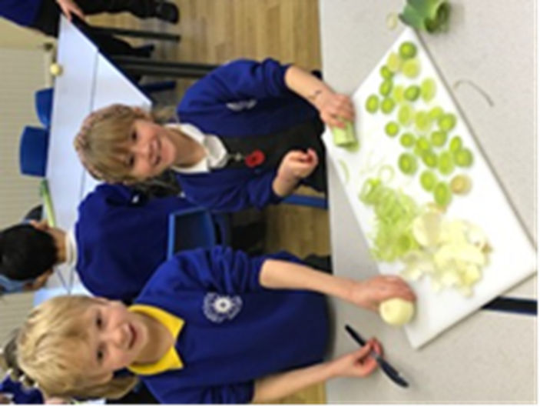
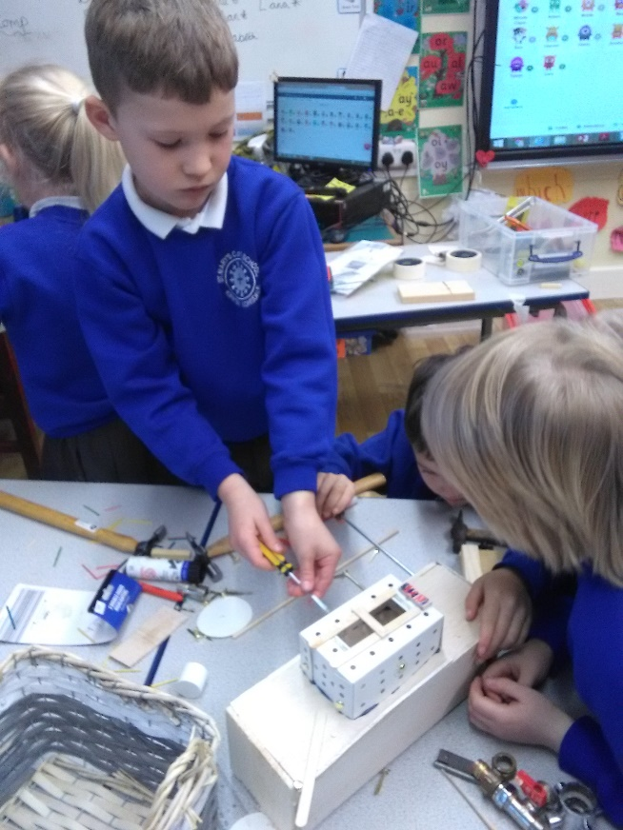
St Mary’s CE School, Kirkby Lonsdale

Introduction

This policy outlines the teaching, organisation and management of Design and Technology taught and learnt at St Mary’s CE School, Kirkby Lonsdale.

The policy has been drawn up as a result of staff discussion and its implementation is the responsibility of all teaching staff. The responsibility for monitoring and review rests with the DT subject leader Melissa Smith.

The main purposes of this policy are:

- To establish an entitlement for all pupils.
- To establish expectations for teachers of this subject.
- To promote continuity and coherence across the school.

Aims and objectives

In our school we want Design and technology to prepare children for the developing world. The subject encourages children to become creative problem-solvers, both as individuals and as part of a team. Through the study of design and technology they combine practical skills with an understanding of aesthetic, social and environmental issues. Design and Technology helps all children to become discriminating and informed consumers and potential innovators. It should assist children in developing a greater awareness and understanding of how everyday products are designed and made.
The aims of design and technology in our school are:
-To develop imaginative thinking in children and to enable them to talk about what they like and dislike when designing and making;
-To enable children to talk about how things work, and to draw and model their ideas;
-To encourage children to select appropriate tools and techniques for making a product, whilst following safe procedures;
- To foster enjoyment, satisfaction and purpose in designing and making;
-To use ICT software to assist our designing and learning.

Teaching and learning style

We use a variety of teaching and learning styles in design and technology lessons. Teachers ensure that the children apply their knowledge and understanding when developing ideas, planning and making products and then evaluating them. We do this through a mixture of whole class teaching and individual/group activities. All ideas will be treated with respect. Children critically evaluate their own work and that of others. They have the opportunity to use a wide range of materials and resources, including ICT.
Children will be given the opportunity to work within three main areas of development during each topic:
1. Investigative, disassembly and evaluative activities
These activities provide opportunities for the children to explore existing products and to gain skills, knowledge and understanding which can be applied in a design and make assignment.
2. Focused practical tasks
Focused practical tasks provide opportunities to learn and practice particular skills and knowledge.
3. Design and make assignments
A design and make assignment provides an opportunity for the children to combine their skills, knowledge and understanding to develop products that meet a real need. (In general DMAs in Key Stage One will tend to be shorter in duration and, as children move towards the end of Key Stage Two, their designing and making will become more complex and therefore more time consuming.)
In all classes there are children of differing ability. We recognise the fact and provide suitable learning opportunities for all children by:

- setting tasks which are open-ended and can have a variety of responses; setting tasks of increasing difficulty, some children not completing all tasks;
- grouping children by ability in the room, and setting different tasks for each ability group; providing resources of different complexity, depending on the ability of the child;
- using teaching assistants to support children individually or in groups.

Promoting key skills through DT
It is vital that skills progress throughout the school; building on the excellent provision and teaching in our Early Years department. Teachers have been given the skills required to teach and it is the coordinators responsibility to monitor and ensure these are being met.

Promoting key vocabulary through DT

Through our teaching of DT, we provide opportunities for pupils to develop the key vocabulary by:
- Kinesthetically and verbally reviewing vocabulary in all lessons
- Displaying vocabulary in books and the school environment
- Encouraging a rich use of vocabulary in learning
- Promoting success of individuals both locally and worldwide

DT curriculum planning
We carry out the curriculum planning in design and technology in three phases: long, medium and short term within/linked to the topic planning. The long-term plan maps out the skills to be covered during the key stages. They identify learning objectives and outcomes for each unit, and ensure an appropriate balance and distribution of work across each term.
We plan the activities in design and technology so that they build upon prior learning of the children. We give children of all abilities the opportunity to develop their skills, knowledge and understanding and we also build planned progression into the scheme of work, so that the children are increasingly challenged as they move through the school.
The planning will be completed through a cross curricular approach ensuring the DT has a link to the topic being studied. Teachers will give each DT theme a purpose.
Each topic will need to be reviewed, informally by the teachers and TA’s within the year group to ascertain the enjoyment had by the children, the effectiveness of developing skills and the quality of purpose.

Responding to pupils’ diverse learning needs – Challenge and Support

At our school we teach DT to all children, whatever their ability and individual need. This is in accordance with the school’s curriculum policy of providing a broad, challenging and balanced education to all children. Through our DT teaching we provide learning opportunities that enable all pupils to make good progress and recall information. We strive hard to meet the needs of those pupils with special educational needs, those with disabilities, those with special abilities and talents, new arrivals and those learning English as an additional language, pupils who are economically disadvantaged and other identified groups and we take all reasonable steps to achieve this.
Teachers’ planning will set high expectations and provide opportunities for all pupils to achieve, so that everyone can take part in lessons fully and effectively. Teachers will take specific action to respond to pupils’ diverse needs by:

- creating effective learning environments; securing their motivation and concentration;
- providing equality of opportunity through teaching approaches – ensuring that children of all intelligences and physical ability are given the opportunity to succeed and make progress;
- using appropriate assessment approaches to inform teaching and learning

Health and safety

We enable all pupils to have access to the full range of activities involved in learning DT. Where children are to participate in activities outside the classroom, teachers should be aware of health and safety issues. Risk assessments are undertaken prior to activities, to ensure that they are safe and appropriate for all pupils. Before undertaking a field trip, teachers are encouraged to visit the proposed area of study and fill in a risk assessment form Via the Kym Allen Health and Safety Website. The Educational Visits Lead is Duncan Bromley.

Design and Technology Policy Statement regarding the use of Food

When working with food:
*An adult will be required to supervise activities involving cooking and food handling/preparation.
*When undertaking food activities the appropriate Health and Safety
Procedures must be adhered to.
*When working with food all children should follow personal hygiene guidance (tie back hair, clean apron, use of blue plasters and washing hands)
*Teachers should check the dietary needs of the children in their class to identify any foods that should not be available to specific children, or groups of children.
*Any perishable food should be stored in a fridge.
*Only the equipment in the food cupboard, which is for food use only, should be used.
*Ensure that the plastic work sheets, especially for use with food, cover the desk area. This sheet should be wiped down with a steriliser.
*Only use equipment set aside to use with food.
*Set aside an area for children to wash their hands.
*Teachers taking part in any food activity should dress appropriately and follow the same procedures as the children with regard to any rules regarding personal hygiene.
*Ensure that all equipment is cleaned and put away in the food cupboard.
*Ensure that all children use their own equipment when tasting food.
*Certain spoons should be identified and used when placing food onto plates for children to taste food, teachers/TA’s need to ensure children do not use their own.

All adults leading DT lessons/ activities should ensure that they have read and understood the D and T Health and Safety section of the Policy.
Adults should ensure that:
DT equipment is not left out and unsupervised, Floors and work surfaces are kept clean and tidy and all tools used must be of good quality, in good condition and stored safely.
Direct safety instructions should be given to children each time they undertake a design and technology activity.
Children should be given suitable instruction on the operation of all equipment before being allowed to work with it.
Children should be strictly supervised in their use of equipment at all times. Adult to child ratio must be appropriate to the activity e.g. closer supervision on activities such as use of a glue gun.
Children should be taught to recognise and consider hazards and risks and to take action to control these risks, having followed simple instructions. Children should be encouraged (at appropriate times) to use the blank risk assessment form to assess the risk of certain activities or tools. A class set of wipe clean forms can be found in the risk assessments folder in with the D and T resources.

Child protection

We seek to safeguard children and young people by:

- valuing them, listening to them and respecting them;
- adopting child protection guidelines through procedures and a code of conduct for staff and volunteers;
- recruiting staff and volunteers safely, ensuring all necessary checks are made;
- sharing information about child protection and good practice with children, parents, staff and volunteers;
- sharing information about concerns, with agencies who need to know, and involving parents and children appropriately;
- providing effective management for staff and volunteers through supervision, support and training.

Assessment for learning and assessment of learning

Teachers assess work in design and technology by making observations of the children working during lessons. They record progress made against the learning objectives for that lesson. At the end of a unit of work, children undertake a review of their work that focuses upon an evaluation of the finished product and an overview of the various tasks undertaken. Teachers complete an outrider assessment against the focus of unit/topic. Teachers make an annual assessment of progress for each child, as part of the annual report to parents. Each teacher passes this information on to the next teacher at the end of each year.

Due to the practical nature of design and technology, evidence of work undertaken by children can be in the form of teacher’s notes or as a photographic record. Samples of the design process and end product are also valuable evidence. These are collected by the coordinator and put together in a file. The design and technology subject coordinator can review evidence of the children’s work in their individual topic boooks.

Resources
We make every effort to ensure that disposable resources, tools and construction kits are available to support all units of work. Teachers are responsible for returning resources tidily and reporting any breakages that need replacing. The resource cupboard will be routinely checked and orders placed as necessary and budget allows.

Monitoring and review

It is the responsibility of the DT subject leader:

- to develop, implement and review an action plan for DT; to monitor DT throughout the school;
- to encourage staff to provide effective learning opportunities for all pupils;
- to develop valid activities, appropriate for children at different stages of development, which enable pupils to progress in the subject.

Monitoring of the standards of children’s work and of the quality of teaching in DT is the responsibility of the DT subject leader. The work of the subject leader also involves supporting colleagues in their teaching, being informed about current developments in the subject, and providing a strategic lead and direction for the subject in the school.

